How to layer things in Microsoft Word
Let’s say that you write a great essay and you want to put some pictures into it. You have a plan that you want to start with a picture on top, then put a picture after the first paragraph, and even have a picture in the background behind the words.
Your essay is about an animal that you have been researching so you need to find a few pictures of it. You really want to impress your teacher by having great facts and great pictures. You know just what to do to make your essay look wonderful.

Directions and Examples:
Word- Part 1
Step 1-
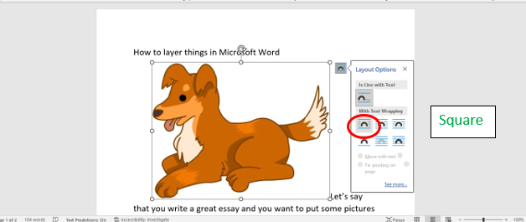

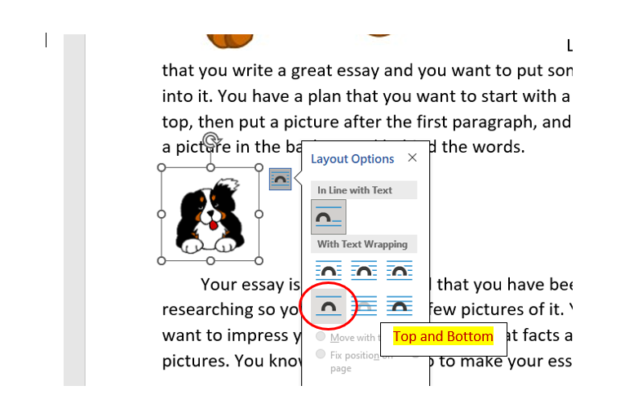
Step 2-

Step 3-
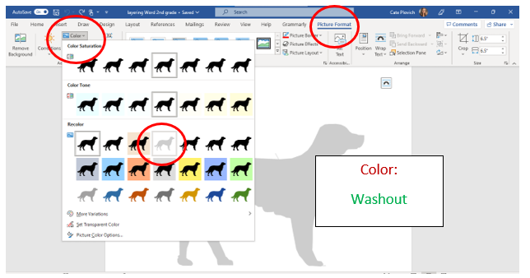

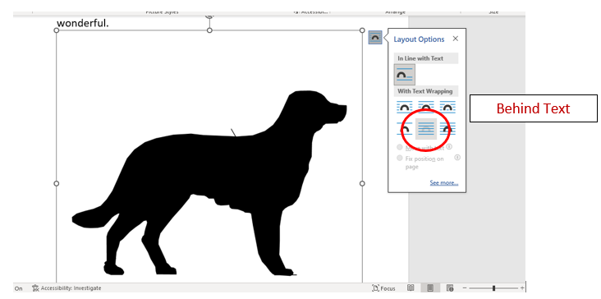
Step 4-

